**ABSTRACT:**

This project involves the development of an advanced health monitoring system designed to enhance the safety and well-being of individuals, particularly those who may be at risk of falls or experiencing temperature abnormalities. The system employs an Arduino-based microcontroller to interface with various sensors for fall detection, temperature monitoring, and battery voltage tracking, offering real-time health data and remote monitoring capabilities. The integration of these features ensures immediate detection and alerts, providing a proactive approach to patient care. The system’s core functionality revolves around three primary sensors: a gyroscope, a temperature sensor, and a voltage sensor. The gyroscope continuously monitors the movements of the user, utilizing its ability to detect rapid or abnormal motions to identify potential falls. This fall detection mechanism is crucial for preventing accidents, particularly for elderly or mobility-impaired individuals. When a fall is detected, the system promptly triggers an alert to notify caregivers, helping to ensure that the person receives timely assistance. Temperature monitoring is another essential feature of the system. A temperature sensor tracks the body temperature of the individual, providing early detection of abnormal temperature fluctuations. If the temperature exceeds a predefined threshold, indicating a fever or other health issues, the system activates a buzzer alert to immediately notify both the user and caregivers. This early-warning system serves as an important safeguard for detecting and addressing potential health concerns before they escalate. Battery monitoring is also a critical aspect of the system’s design. A voltage sensor tracks the health of the system’s battery, providing real-time feedback on the battery level. If the battery voltage drops below a certain threshold, indicating a need for recharging or replacement, an alert is generated to prevent system failure. This ensures that the monitoring system operates continuously without interruption, offering reliable performance when needed most. All sensor data is processed by the Arduino microcontroller, which evaluates the incoming readings for abnormal conditions such as high temperature or a fall event. Based on the data, the microcontroller triggers the appropriate alerts and updates the system’s display. Real-time health data, including the body temperature and fall status, is shown on an LCD screen, providing immediate feedback for the user or their caregivers. This display allows for quick assessment of the individual’s condition and facilitates quick intervention if necessary. IoT functionality to enable remote monitoring. The collected data is transmitted to a cloud platform or mobile device, allowing caregivers to monitor the user’s health in real-time, even when they are not physically present.

**OBJECTIVE:**

* Develop a system capable of accurately measuring vital health parameters in real time, ensuring timely access to critical health data for improved self-management and proactive healthcare.
* Provide an intuitive display for clear visualization of health metrics, making the system accessible to individuals with varying levels of technical expertise and supporting seamless user interaction.
* Enable remote monitoring and data sharing via IoT technology, facilitating real-time access for healthcare providers and creating opportunities for advanced telemedicine and remote health management applications.
* Incorporate battery voltage monitoring to optimize energy usage, ensuring uninterrupted operation and reliability in both stationary and mobile environments, enhancing the system's usability and practicality.
* Design a flexible system architecture to accommodate future enhancements, including advanced analytics, additional features, and interoperability with other smart healthcare devices for long-term adaptability.
* Validate the system through thorough testing and calibration, ensuring precise, consistent health measurements under diverse conditions, and establishing its dependability for personal and professional healthcare applications.

**CHAPTER 1**

**INTRODUCTION**

In recent years, the development of health monitoring systems has become increasingly critical due to the rising demand for efficient and reliable solutions that ensure the safety and well-being of individuals, particularly those with specific health conditions or vulnerabilities. A growing aging population, coupled with an increase in chronic diseases and mobility impairments, has highlighted the necessity for continuous monitoring and early intervention systems that can proactively detect health concerns and prevent emergencies. These concerns have catalyzed the need for more advanced and accessible health monitoring systems, particularly those that are user-friendly, scalable, and capable of providing real-time data to caregivers and medical professionals. Among the many health risks that individuals face, falls, temperature fluctuations, and battery failures are significant threats that need constant attention. Falls are a leading cause of injury, particularly among the elderly and those with mobility limitations. According to the World Health Organization (WHO), falls are the second leading cause of unintentional injury death globally, and they can lead to severe outcomes such as fractures, head trauma, and even death. The impact of a fall can be compounded by delayed detection, especially when the person is unable to call for help. Similarly, abnormal body temperature, particularly fever or hypothermia, is often indicative of underlying health issues such as infection, dehydration, or other serious medical conditions. Early detection of abnormal temperatures is crucial for timely medical intervention to prevent further complications. In addition to fall detection and temperature monitoring, a common issue with health monitoring systems is the failure to maintain operational functionality due to battery depletion. For systems that rely on constant operation, such as those designed for vulnerable individuals, uninterrupted functionality is essential to ensure consistent health monitoring and alerting. Therefore, the integration of a battery monitoring system that provides early warnings of low battery levels is an essential feature to prevent potential failures, ensuring the continuity of critical alerts and health data collection. This project aims to address these pressing issues by developing a comprehensive health monitoring system that incorporates fall detection, temperature monitoring, and battery voltage tracking. The system leverages an Arduino-based microcontroller, which interfaces with a variety of sensors, including a gyroscope, temperature sensor, and voltage sensor. The sensors work together to monitor the user’s health in real-time, providing immediate feedback through a local display and alerts to caregivers. Additionally, IoT functionality is integrated into the system to facilitate remote monitoring, allowing caregivers to receive real-time updates and alerts on their mobile devices or cloud platforms. This remote access enhances the caregivers’ ability to respond to health issues swiftly, even when they are not physically present. The central aspect of the system is the gyroscope, which continuously monitors the user's movements to detect any rapid or abnormal motions indicative of a fall. This gyroscope-based fall detection system is designed to ensure that caregivers are immediately alerted if a fall occurs, thereby allowing for quick intervention and reducing the risk of complications due to delayed assistance. Fall detection is critical for individuals at risk of falling, including the elderly, people with disabilities, and those undergoing rehabilitation after surgery or injury. The system’s ability to trigger real-time alerts based on the fall detection algorithm can be lifesaving, particularly in situations where the person is unable to communicate their condition. Another key feature of this system is the integration of a temperature sensor to continuously monitor the user’s body temperature. Temperature fluctuations, such as a sudden fever or a dangerously low body temperature, can indicate an underlying health issue that requires immediate attention. In many cases, these changes in temperature can be subtle but lead to serious complications if not addressed promptly. By detecting temperature abnormalities, the system provides early warnings, triggering an alert to notify caregivers or healthcare providers so that appropriate measures can be taken. This temperature monitoring feature adds a crucial layer of protection, especially for individuals who may not be able to communicate their discomfort or symptoms effectively. In addition to fall and temperature monitoring, ensuring the operational efficiency of the system is paramount. The integration of a voltage sensor is essential to track the health of the system's battery. A low battery can render the system ineffective, leading to missed alerts and failure to monitor the user’s health. To mitigate this risk, the system is designed to monitor battery levels continuously and send alerts when the battery voltage drops below a predetermined threshold. This feature ensures that caregivers are notified when it is time to recharge or replace the battery, preventing the system from becoming non-functional during critical times. The data collected by the sensors is processed by the Arduino microcontroller, which evaluates the incoming readings and checks for abnormal values. If the system detects a fall event, a high body temperature, or low battery levels, it triggers the appropriate alerts, either through a local buzzer or by sending notifications to caregivers via IoT integration. In addition to local alerts, the system also features an LCD screen that displays real-time health data, including body temperature and fall status. This provides immediate feedback to users and caregivers, allowing them to assess the individual’s condition and take necessary action promptly. For caregivers, this feature ensures that they have access to vital health information at all times. One of the most impactful aspects of this system is its IoT functionality. IoT-enabled health monitoring allows caregivers to monitor their loved ones remotely, receiving real-time data on their health status via a mobile device or cloud platform. This remote monitoring capability is particularly useful for individuals who live alone or when caregivers are not physically present. The system provides timely alerts about critical health events, such as falls or temperature fluctuations, ensuring that caregivers can take immediate action, regardless of their physical location. This feature enhances caregiver peace of mind, knowing that they will be notified in real time when their loved one’s health status changes. The development of this health monitoring system represents a significant step forward in providing comprehensive, real-time, and remote health monitoring for individuals at risk of falls, temperature abnormalities, and battery failure. By combining fall detection, temperature monitoring, and battery tracking with IoT integration, this system offers a holistic approach to health management. The system’s ability to detect critical health events and send real-time alerts ensures that caregivers can intervene promptly, reducing the risks associated with delayed intervention. As the demand for efficient health monitoring solutions continues to grow, this system serves as a model for future advancements in healthcare technology, offering a reliable and accessible solution for improving patient safety and well-being.

**1.1 INTERNET OF THINGS**

The Internet of Things (IoT) is the network of devices such as vehicles, and home appliances that contain electronics, software, actuators, and connectivity which allows these things to connect, interact and exchange data. The IoT involves extending Internet connectivity beyond standard devices, such as desktops, laptops, smartphones and tablets, to any range of traditionally dumb or non-internet-enabled physical devices and everyday objects. Embedded with technology, these devices can communicate and interact over the Internet, and they can be remotely monitored and controlled.

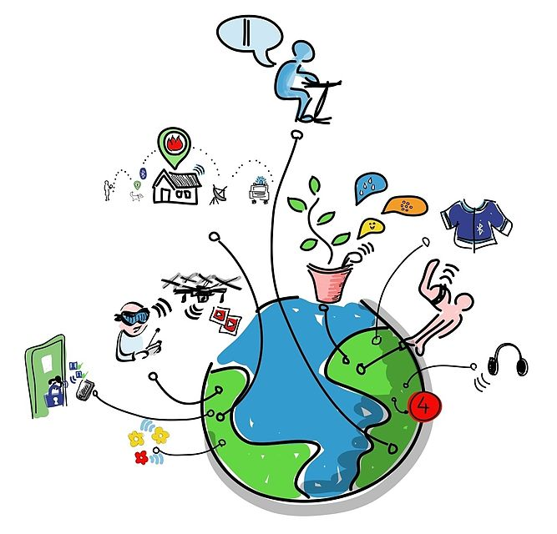

Fig:1.1 Representation of IoT

The definition of the Internet of things has evolved due to convergence of multiple technologies, real-time analytics, machine learning, commodity sensors, and embedded systems. Traditional fields of embedded systems, wireless sensor networks, control systems, automation (including home and building automation), and others all contribute to enabling the Internet of things.

**1.2 HOW IOT WORKS**

An IoT ecosystem consists of web-enabled smart devices that use embedded processors, sensors and communication hardware to collect, send and act on data they acquire from their environments. IoT devices share the sensor data they collect by connecting to an IoT gateway or other edge device where data is either sent to the cloud to be analyzed or analyzed locally. Sometimes, these devices communicate with other related devices and act on the information they get from one another. The devices do most of the work without human intervention, although people can interact with the devices -- for instance, to set them up, give them instructions or access the data. The connectivity, networking and communication protocols used with these web-enabled devices largely depend on the specific IoT applications deployed.

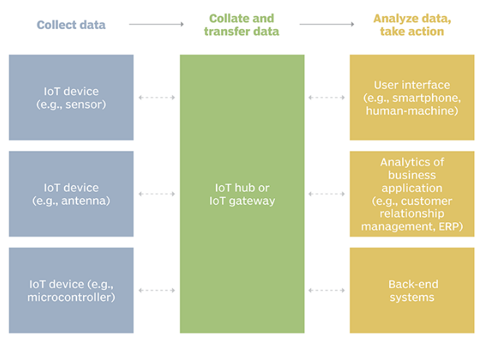

Fig1.2: Example of an IOT system

**1.3 BENEFITS OF IOT**

The internet of things offers a number of benefits to organizations, enabling them to:

* monitor their overall business processes;
* improve the customer experience;
* save time and money;
* enhance employee productivity;
* integrate and adapt business models;
* make better business decisions; and
* Generate more revenue.

IoT encourages companies to rethink the ways they approach their businesses, industries and markets and gives them the tools to improve their business strategies.

### 1.4 IOT SECURITY AND PRIVACY ISSUES

The internet of things connects billions of devices to the internet and involves the use of billions of data points, all of which need to be secured. Due to its expanded attack surface, IoT security and IoT privacy are cited as major concerns.

One of the most notorious recent IoT attacks was Mirai, a botnet that infiltrated domain name server provider Dyn and took down many websites for an extended period of time in one of the biggest distributed denial-of-service (DDoS) attacks ever seen. Attackers gained access to the network by exploiting poorly secured IoT devices.

Because IoT devices are closely connected, all a hacker has to do is exploit one vulnerability to manipulate all the data, rendering it unusable. And manufacturers that don't update their devices regularly -- or at all -- leave them vulnerable to cybercriminals.

Additionally, connected devices often ask users to input their personal information, including names, ages, addresses, phone numbers and even social media accounts -- information that's invaluable to hackers.

However, hackers aren't the only threat to the internet of things; privacy is another major concern for IoT users. For instance, companies that make and distribute consumer IoT devices could use those devices to obtain and sell users' personal data.

Beyond leaking personal data, IoT poses a risk to critical infrastructure, including electricity, transportation and financial services.

**1.5 IOT APPLICATION AREAS**

Near Field Communication (NFC), Radio frequency Identification (RFID), Machine-to-Machine Communication (M2M) & Vehicle-to-Vehicle Communication (V2V) are the technologies by which IoT is being implemented exponentially. It is assumed that more than 50 billion IoT devices will be connected through internet. It is going to change human life, working style, entertaining ways and many more. IoT have many Applications Areas and domain of these application are increasing day by day.

There are ample of applications of IoT as follow:

• Smart Cities

• Building & Home automation

• Environmental Monitoring

• Automotive Industry

• Smart Retail

• Smart Agriculture

• Smart Industry

• Energy Management

• Healthcare Monitoring

**1.6 EMBEDDED SYSTEM**

An embedded system is one kind of a computer system mainly designed to perform several tasks like to access, process, store and also control the data in various electronics-based systems. Embedded systems are a combination of hardware and software where software is usually known as firmware that is embedded into the hardware. One of its most important characteristics of these systems is, it gives the o/p within the time limits. Embedded systems support to make the work more perfect and convenient. So, we frequently use embedded systems in simple and complex devices too. The applications of embedded systems mainly involve in our real life for several devices like microwave, calculators, TV remote control, home security and neighborhood traffic control systems, etc.

An embedded system is integration of hardware and software, the software used in the embedded system is set of instructions which are termed as a program. The microprocessors or microcontrollers used in the hardware circuits of embedded systems are programmed to perform specific tasks by following the set of instructions. These programs are primarily written using any programming software like Proteus or Lab-view using any programming languages such as C or C++ or embedded C. Then, the program is dumped into the microprocessors or microcontrollers that are used in the embedded system circuits.

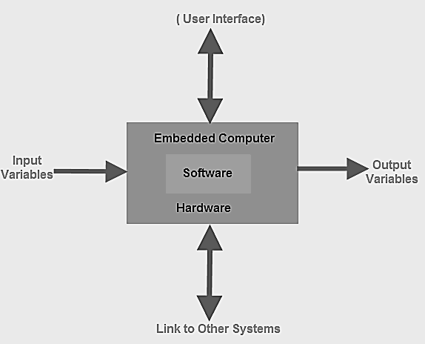

### Embedded System Classification

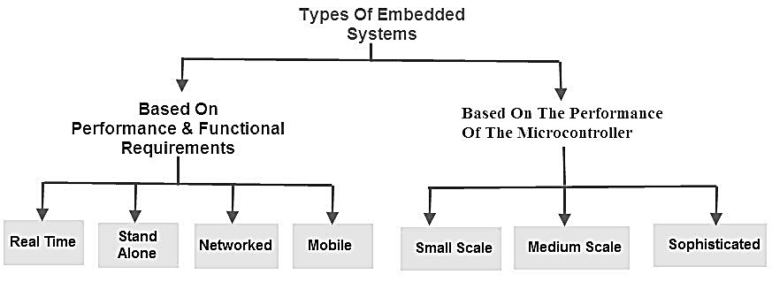

Embedded systems are primarily classified into different types based on complexity of hardware & software and microcontroller (8 or 16 or 32-bit). Thus, based on the performance of the microcontroller, embedded systems are classified into three types such as:

* Small scale embedded systems
* Medium scale embedded systems
* Sophisticated embedded systems

Further, based on performance and functional requirements of the system embedded system classified into four types such as:Real time embedded systems

* Standalone embedded systems
* Networked embedded systems
* Mobile embedded systems

**Embedded System Hardware**

An embedded system uses a hardware platform to perform the operation. Hardware of the embedded system is assembled with [a microprocessor/microcontroller](https://www.elprocus.com/microprocessor-and-microcontroller/). It has the elements such as input/output interfaces, memory, user interface and the display unit. Generally, an embedded system comprises of the following

* [Power Supply](https://www.elprocus.com/switch-mode-power-supply-working/)
* Memory
* Processor
* Timers
* Output/Output circuits
* Serial communication ports
* SASC (System application specific circuits)

**Embedded System Software**

The[software of an embedded system is written](https://www.elprocus.com/embedded-system-programming-using-keil-c-language/) to execute a particular function. It is normally written in a high-level setup and then compiled down to offer code that can be stuck within a non-volatile memory in the hardware. Embedded system software is intended to keep in view of the following three limits

* Convenience of system memory
* Convenience of processor’s speed
* When the embedded system runs constantly, there is a necessity to limit power dissipation for actions like run, stop and wake up.

#### RTOS (Real Time Operating System)

A system which is essential to finish its task and send its service on time, then only it said to be a real time operating system. RTOS controls the application software and affords a device to allow the processor run. It is responsible for managing the different hardware resources of a personal computer and also host applications which run on the PC.

This operating system is specially designed to run various applications with an exact timing and a huge amount of consistency. Particularly, this can be significant in measurement & industrial automation systems where a delay of a program could cause a safety hazard.

#### Memory and Processors

The different kinds of processors used in an embedded system include Digital Signal Processor (DSP), microprocessor, RISC processor, microcontroller, ASSP processor, ASIP processor, and ARM processor. The different types of memories of an embedded system are given in the below chart.

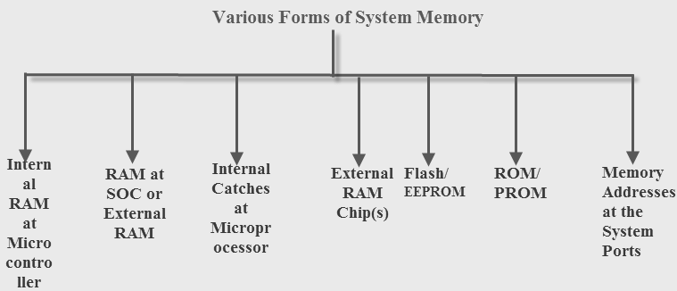

**Embedded System Characteristics**

* Generally, an embedded system executes a particular operation and does the similar continually. For instance: A pager is constantly functioning as a pager.
* All the computing systems have limitations on design metrics, but those can be especially tight. Design metric is a measure of an execution features like size, power, cost and also performance.
* It must perform fast enough and consume less power to increase battery life.
* Several embedded systems should constantly react to changes in the system and also calculate particular results in real time without any delay. For instance, a car cruise controller; it continuously displays and responds to speed & brake sensors. It must calculate acceleration/de-accelerations frequently in a limited time; a delayed computation can consequence in letdown to control the car.
* It must be based on a microcontroller or microprocessor based.
* It must require a memory, as its software generally inserts in ROM. It does not require any secondary memories in the PC.
* It must need connected peripherals to attach input & output devices.
* An Embedded system is inbuilt with hardware and software where the hardware is used for security and performance and Software is used for more flexibility and features.

### Embedded System Applications

The applications of an embedded system basics include smart cards, computer networking, satellites, telecommunications, digital consumer electronics, missiles, etc.

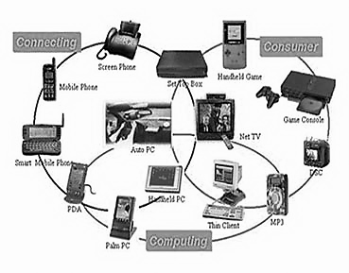

* Embedded systems in automobiles include motor control, cruise control, body safety, engine safety, robotics in an assembly line, car multimedia, car entertainment, E-com access, mobiles etc.
* Embedded systems in telecommunications include networking, mobile computing, and wireless communications, etc.
* [Embedded systems in smart cards](https://www.elprocus.com/working-of-smart-card/) include banking, telephone and security systems.
* Embedded Systems in satellites and missiles include defense, communication, and aerospace.

**CHAPTER 2**

**LITERATURE SURVEY**

**2.1 INTRODUCTION**

Wearable health monitoring technologies have evolved significantly in recent years, driven by advancements in the Internet of Things (IoT), machine learning, and sensor technology. With an aging global population and a rising prevalence of chronic diseases, healthcare systems are increasingly focusing on proactive monitoring solutions to enhance patient care, reduce hospital visits, and enable timely interventions. Wearable devices and remote monitoring systems provide a pathway for continuous health surveillance, improving patient autonomy and fostering a shift from reactive to preventive healthcare. Key areas of focus within this domain include fall detection, pressure ulcer prevention, and chronic disease management. These systems leverage wearable sensors, cloud computing, and machine learning algorithms to monitor and analyze patient data in real time, enabling personalized healthcare and early detection of potential health issues.

This literature survey provides a comprehensive review of the current state of wearable and remote health monitoring systems, highlighting their applications, benefits, and challenges. Studies in this survey explore various approaches, including the use of smartwatches and smartphones for fall detection in elderly patients, IoT-enabled devices for chronic disease management, and AI-powered smart mattresses to prevent pressure ulcers in immobile patients. Each study emphasizes the role of machine learning in analyzing sensor data, enhancing accuracy, and minimizing false alerts, which is critical for real-world applications. While these technologies promise substantial improvements in healthcare delivery, the literature identifies challenges such as sensor accuracy, data security, interoperability, and user engagement. Addressing these challenges is essential to maximizing the benefits of wearable and IoT-based health monitoring solutions.

2.2 REVIEWS OF VARIOUS TOPOLOGIES

[1]Zhang and Wang explore the implementation of wearable sensors combined with machine learning algorithms for fall detection in elderly individuals, focusing on improving safety and response times. The authors integrate accelerometers and gyroscopes, embedded in wearable devices such as smartwatches, to monitor daily movements. These sensors continuously capture data on the user’s posture and motion, feeding it into machine learning models trained to distinguish between typical activities and falls. The study evaluates multiple machine learning techniques, including decision trees, support vector machines (SVM), and deep learning models, assessing their effectiveness in real-time fall detection. A key focus of this research is the accuracy of detecting falls in real-world settings, where the system must minimize false positives (incorrectly identifying normal activities as falls) and false negatives (failing to detect an actual fall). Zhang and Wang address the challenges of sensor data noise and environmental factors that can affect sensor readings. The research also discusses the importance of context in fall detection, where the system must differentiate between harmless activities like sitting down or bending over and dangerous falls. The authors propose a hybrid fall detection algorithm that combines sensor fusion techniques and machine learning models to enhance accuracy. The study highlights the significant potential of such wearable fall detection systems, noting that they could greatly improve elderly care by reducing the response time to falls. It also emphasizes the integration of alerts to caregivers, hospitals, and emergency responders, ensuring immediate assistance in case of a fall. However, limitations such as battery life, wearable comfort, and the need for personalized fall detection models are identified as key areas for improvement. The conclusion of this study stresses the importance of wearable fall detection systems in elderly care and rehabilitation, suggesting that their widespread adoption could reduce fall-related injuries and enhance elderly autonomy. The authors also note that further research and collaboration with healthcare professionals are needed to refine these systems and ensure they work across diverse patient populations.

[2]Johnson and Lee examine the use of smart health monitoring systems for remote monitoring of patients with chronic diseases, such as diabetes, hypertension, and cardiovascular diseases. The paper explores the growing role of the Internet of Things (IoT) in healthcare, where various wearable devices equipped with sensors track physiological parameters like heart rate, blood pressure, glucose levels, and oxygen saturation. The system transmits real-time health data to cloud platforms, enabling healthcare providers to monitor patients remotely. This real-time monitoring is critical for ensuring continuous care, reducing hospital visits, and preventing potential emergencies due to unmanaged chronic conditions. The authors highlight the integration of machine learning algorithms with sensor data to predict potential health risks and alert healthcare professionals before complications arise. For example, the system can notify caregivers if a patient’s blood pressure reaches dangerous levels, or if glucose levels are too high, triggering immediate interventions. The ability to continuously track and analyze health data also enhances personalized healthcare plans, as the system learns from patient trends and offers tailored recommendations. In terms of system architecture, the paper discusses how cloud computing enables the secure storage and analysis of patient data, supporting real-time decision-making. Additionally, mobile applications that sync with the health monitoring devices are discussed, enabling patients to track their health metrics easily. The authors also emphasize the importance of patient engagement in remote health monitoring systems, where patient involvement in tracking their health and following treatment recommendations plays a crucial role in improving health outcomes. Despite its potential, the study addresses several challenges, such as the need for interoperability between different health devices and platforms, concerns over patient data privacy and security, and the accessibility of these systems for underserved populations. Johnson and Lee conclude by stating that IoT-based health monitoring systems can significantly reduce healthcare costs and improve patient outcomes. They also call for more research into the long-term effectiveness and integration of these systems into mainstream healthcare practices.

[3]Kumar and Singh delve into the development of an IoT-based patient monitoring system using wearable devices for continuous health tracking. Their study presents a solution where patients wear devices embedded with sensors that measure vital signs such as heart rate, blood pressure, body temperature, and blood oxygen levels. The system transmits this data wirelessly to a central cloud platform, where healthcare providers can access it in real time, allowing for remote monitoring and timely intervention if any abnormalities are detected. The authors highlight the role of machine learning algorithms in analyzing patient data. These algorithms identify trends, predict potential health risks, and alert healthcare professionals if critical values exceed predefined thresholds. For instance, the system can detect a sudden spike in blood pressure or an abnormal heart rate, signaling that medical intervention may be required. By integrating machine learning, the system also adapts to the individual’s baseline health metrics, improving the accuracy of alerts over time. The paper also discusses the integration of this system with electronic health records (EHR) to provide a holistic view of a patient's health status. Real-time data allows for adjustments in treatment plans based on the patient’s current condition. Moreover, the study emphasizes the importance of user-friendly interfaces for both patients and healthcare providers, ensuring that the monitoring system is accessible and effective for diverse populations, including elderly patients who may not be tech-savvy. However, the authors acknowledge challenges in device calibration, sensor accuracy, and the need for standardization across healthcare devices. They also discuss the potential for data overload, where healthcare providers may struggle to manage vast amounts of real-time data from multiple patients. To mitigate these issues, the study proposes filtering mechanisms and alert prioritization to highlight only the most critical patient data. The conclusion stresses the significant promise of IoT-based patient monitoring systems, not only for chronic disease management but also for post-operative recovery, preventive healthcare, and the general health and wellness of patients. The authors suggest that more research and collaboration with medical institutions are required to optimize such systems for widespread use.

[4] Chang and Lee investigate the use of smart mattress technology as a solution to prevent pressure ulcers in patients who are bedridden or have limited mobility. Pressure ulcers, also known as bedsores, are a common and severe issue for individuals who are unable to reposition themselves frequently. The study discusses how smart mattresses, equipped with pressure-sensing technology, can continuously monitor the distribution of pressure on a patient's body. These sensors detect high-pressure areas in real time and alert caregivers to reposition the patient, thereby preventing the development of pressure ulcers. The authors highlight that the smart mattresses use multiple sensors embedded within the mattress surface to gather data on pressure distribution. This data is processed to identify critical pressure points that could lead to skin damage. If a high-pressure area is detected, an alert is triggered, notifying caregivers to reposition the patient. The authors emphasize that early detection is crucial, as repositioning within the first few hours of pressure build-up can significantly reduce the risk of pressure ulcers. In addition to real-time pressure monitoring, the study also explores the potential for integrating smart mattresses with electronic health records (EHR). This integration allows for seamless tracking of patient comfort levels and pressure ulcer prevention efforts, providing caregivers with detailed reports on patient care. Moreover, the study examines the use of machine learning algorithms to predict pressure ulcer risk based on patient factors such as mobility, nutrition, and existing health conditions. While the technology shows significant promise, the authors note challenges such as the high cost of smart mattresses, the need for proper sensor calibration, and the potential for sensor discomfort in patients. They also discuss the importance of training healthcare staff to effectively use these systems. The paper concludes by suggesting that smart mattress technology, when used proactively, can reduce the incidence of pressure ulcers, enhance patient comfort, and improve overall healthcare outcomes.

[5] Lee and Kim present a fall detection and alerting system that utilizes smartphone sensors, including accelerometers and gyroscopes, to monitor elderly individuals’ movements. This system addresses the growing need for fall detection devices that are both accessible and cost-effective. Smartphones, being ubiquitous, provide a practical alternative to wearable fall detection devices. The system continuously collects sensor data to detect sudden, unexpected movements indicative of a fall. The study focuses on the design and evaluation of algorithms that can accurately detect falls based on sensor data. The authors examine various machine learning techniques to improve the reliability and accuracy of the system, especially in differentiating between falls and other common activities like sitting down or bending over. A key challenge discussed is minimizing false positives, as many fall detection systems trigger alerts for normal activities, which could lead to unnecessary panic or caregiver intervention. The real-time aspect of the system is particularly emphasized, with alerts being sent to designated emergency contacts or healthcare providers if a fall is detected. This quick response could significantly reduce the time between a fall and medical intervention, which is crucial for preventing further injury. Additionally, the system also includes an automatic call feature, which contacts emergency services in the event that no response is received from the patient after the alert. Lee and Kim's study discusses the practicality of implementing smartphone-based fall detection systems in real-world scenarios. They highlight the advantages of using smartphones, such as the wide availability of the devices and their affordability compared to specialized fall detection wearables. However, they also point out the challenges of ensuring accurate fall detection in a wide range of environments and activities. For instance, falls may occur in places with insufficient sensor coverage, or during activities that mimic fall-like movements. In conclusion, the authors advocate for the integration of smartphone sensors with fall detection algorithms as a promising, low-cost solution for elderly fall prevention. The study suggests further improvements in the system’s accuracy and responsiveness could enhance its adoption, particularly in elder care settings.

[6] Huang and Zhou explore the use of wearable sensors for continuous health monitoring in elderly patients, focusing on early detection of health issues and enhancing the quality of care for aging populations. The study presents a comprehensive system that integrates various sensors, such as heart rate monitors, accelerometers, and temperature sensors, to track key physiological parameters. These devices are worn on the body and transmit real-time data to a central platform where healthcare providers can monitor patient health remotely. The authors highlight the integration of these sensors with machine learning algorithms that can detect anomalies in real-time. For instance, abnormal heart rate patterns or sudden changes in activity levels may indicate early signs of heart failure or other critical health conditions. The system can automatically alert healthcare providers, family members, or caregivers, facilitating timely intervention and preventing adverse events. One of the key benefits of this system is its ability to provide real-time feedback, which is especially important in the management of chronic diseases. By continuously tracking vital signs and physical activity, caregivers can adjust treatment plans based on real-time data. Furthermore, the use of wearable sensors minimizes the need for frequent doctor visits, which can be burdensome for elderly patients, particularly those with mobility challenges. Despite the promising applications, the study acknowledges several challenges in the widespread adoption of wearable sensors. These challenges include sensor accuracy, battery life, user comfort, and the need for seamless integration with existing healthcare infrastructure, such as electronic health records (EHR). Additionally, the authors discuss the privacy concerns surrounding the continuous collection of sensitive health data, emphasizing the need for secure data transmission and storage. The study concludes that wearable sensors can significantly improve the healthcare management of elderly patients by enabling early detection of health issues, reducing emergency hospital visits, and providing a higher level of patient autonomy. However, the authors suggest further research to improve the reliability of the sensors, enhance user comfort, and ensure data security.

[7] Patel and Gupta propose an AI-based monitoring system designed to prevent pressure ulcers in ICU patients. Pressure ulcers, also known as bedsores, are a common complication for patients who are immobile or bedridden for extended periods. The authors present an innovative system that combines pressure-sensing technology with artificial intelligence (AI) to continuously monitor patients' positions and identify areas of high pressure on the body. The system analyzes data from pressure sensors embedded in hospital beds or mattresses to detect pressure points that could lead to skin breakdown. The paper outlines the role of AI in processing sensor data to predict the risk of pressure ulcers based on individual patient characteristics, including mobility, nutrition, and skin condition. The system uses machine learning algorithms to classify patients into different risk categories, enabling personalized care plans. The AI system can also provide real-time alerts to healthcare providers, notifying them when a patient needs to be repositioned to alleviate pressure and prevent the formation of pressure ulcers. A significant aspect of the research is the integration of this system with hospital management software, enabling healthcare providers to track patient progress and care interventions. This integration ensures that caregivers have access to actionable data, such as the frequency of repositioning, skin condition reports, and the overall effectiveness of pressure ulcer prevention strategies. However, the study identifies several challenges in the implementation of AI-based systems in healthcare, such as the need for robust training data, sensor calibration, and system validation. The authors also address concerns about the cost of AI-driven solutions and the need for hospital staff to be trained in using these new technologies. In conclusion, Patel and Gupta highlight the potential of AI-based monitoring systems in reducing the incidence of pressure ulcers in ICU patients, thereby improving patient outcomes and reducing the burden on healthcare staff. They recommend further research and development to refine the technology and improve its implementation in clinical settings.

[8] Tan and Lim present a smart healthcare system that integrates the Internet of Things (IoT) with machine learning techniques to manage chronic diseases such as diabetes, hypertension, and asthma. The system leverages IoT-enabled devices, including glucose meters, blood pressure monitors, and inhalers, which continuously collect data on patients' health metrics. The real-time data is transmitted to cloud platforms, where machine learning algorithms analyze the information to identify patterns and predict potential health issues. The study emphasizes the importance of personalized healthcare through the use of machine learning models that tailor treatment plans based on the individual’s health data. For example, the system can predict when a patient’s glucose levels are likely to fluctuate or when blood pressure is trending towards unsafe levels. These insights enable healthcare providers to intervene proactively, adjusting medication or recommending lifestyle changes before issues become severe. In addition to monitoring, the system provides alerts to both patients and caregivers when abnormal readings are detected, such as dangerously high blood pressure or low blood sugar. The authors also discuss the integration of this system with mobile health applications, allowing patients to track their health data on their smartphones and receive personalized health advice. While the system shows promise for improving chronic disease management, the authors note challenges in terms of data accuracy, sensor reliability, and the need for comprehensive training for both patients and healthcare professionals. The paper also addresses the potential for data privacy concerns, emphasizing the importance of secure data transmission and storage. In conclusion, Tan and Lim advocate for the integration of IoT and machine learning technologies in chronic disease management, arguing that these systems can significantly enhance patient outcomes and reduce healthcare costs by preventing complications and promoting proactive care.

[9] Nguyen and Tran provide a comprehensive review of remote patient monitoring (RPM) technologies using IoT devices, exploring their potential applications in managing various health conditions, particularly chronic diseases. The paper discusses the rapid growth of IoT technologies in healthcare and their capacity to offer real-time monitoring of vital signs, such as heart rate, blood pressure, oxygen saturation, and body temperature. These devices can be worn by patients and transmit data wirelessly to healthcare providers, enabling continuous health surveillance outside of traditional clinical settings. The authors explore several types of IoT-enabled devices, including wearable sensors, home-based health monitoring kits, and even smart inhalers for respiratory conditions. The paper emphasizes how IoT devices facilitate the management of chronic diseases by providing continuous, data-driven insights into a patient’s condition, reducing the need for frequent hospital visits and enabling earlier interventions when health deteriorates. In particular, the study focuses on the integration of IoT devices with cloud computing platforms, which store and analyze the collected data. By leveraging cloud-based platforms, healthcare providers can monitor multiple patients simultaneously and access real-time health data, enhancing their ability to make informed decisions. Additionally, machine learning algorithms are integrated into the system to analyze patterns in the data and predict potential health risks, such as heart attacks or diabetic episodes. The review also covers the challenges of RPM, including issues related to sensor accuracy, data security, and the need for standardized protocols for data exchange across different devices and platforms. Furthermore, the authors highlight the need for patient education and engagement to ensure that patients can effectively use IoT devices and integrate them into their daily routines. Nguyen and Tran conclude that RPM using IoT devices has the potential to revolutionize healthcare by improving patient outcomes, reducing costs, and enhancing the quality of care. They call for further research into the interoperability of IoT devices and more robust validation studies to ensure their efficacy in clinical settings.

[10] Carter and Williams explore the application of machine learning techniques for the early detection of pressure injuries, such as pressure ulcers, in healthcare settings. Pressure injuries are a significant concern for patients with limited mobility, particularly those in long-term care facilities or intensive care units. The authors discuss how machine learning can be used to analyze sensor data, such as pressure measurements from smart mattresses or wearables, to predict the risk of pressure injuries before they occur. The study focuses on developing machine learning models that can process real-time sensor data to assess pressure distribution and detect areas at risk of developing ulcers. The authors review several machine learning algorithms, including decision trees, neural networks, and support vector machines (SVM), evaluating their performance in predicting pressure injury risk based on historical patient data. By combining pressure-sensing technology with machine learning, the system can provide early warnings and suggest preventive measures, such as repositioning the patient or altering their care regimen. The authors also explore the potential integration of these predictive models with hospital information systems, where alerts can be sent directly to healthcare providers. Despite the promising outcomes, the study addresses challenges such as the need for large datasets to train the machine learning models, the variability of sensor data across different patient populations, and the complexities of implementing these systems in real-world clinical environments. The authors emphasize the need for ongoing validation and refinement of the algorithms to ensure their reliability. In conclusion, Carter and Williams argue that machine learning-driven early detection systems could play a critical role in preventing pressure injuries, improving patient outcomes, and reducing healthcare costs. They suggest that further research and collaboration between healthcare professionals and data scientists are necessary to optimize these systems for clinical use.

2.3 SUMMARY

The literature on wearable health monitoring systems presents a diverse range of applications aimed at improving patient outcomes, particularly for elderly and chronically ill individuals. Key studies include Zhang and Wang's research on wearable fall detection systems, which use accelerometers and gyroscopes combined with machine learning to reduce response times to falls. Similarly, Johnson and Lee's study on IoT-enabled monitoring systems for chronic disease management highlights the importance of continuous monitoring and personalized healthcare, while Kumar and Singh focus on the integration of these systems with electronic health records (EHR) to provide a comprehensive view of patient health. In the realm of pressure ulcer prevention, Chang and Lee, and Patel and Gupta demonstrate how smart mattresses and AI-driven systems can predict and prevent bedsores in immobile patients by monitoring pressure points and alerting caregivers.

Across these studies, machine learning algorithms play a central role, enhancing the systems’ ability to analyze trends, predict risks, and provide real-time alerts. However, challenges such as device calibration, sensor accuracy, and data privacy persist. Authors also highlight the need for interoperable systems that can integrate seamlessly with existing healthcare infrastructures. While promising, the research underscores the need for further validation and collaboration with healthcare professionals to optimize these technologies for widespread adoption. The findings suggest that wearable health monitoring systems have the potential to transform patient care, reduce healthcare costs, and promote a proactive approach to healthcare management.

**CHAPTER 3**

**3.1 EXISTING SYSTEM**

Existing systems in patient monitoring and comfort management utilize various technologies to address health concerns such as pressure ulcers, falls, vital sign monitoring, and chronic disease management. Pressure-sensing technology is widely used in healthcare facilities, particularly in beds or mattresses, to monitor the distribution of pressure on a patient’s body. These systems use sensors to detect high-pressure areas that could potentially lead to pressure ulcers. Smart mattresses, for example, are equipped with pressure sensors that continuously monitor the patient’s position and redistribute pressure when necessary. Some advanced systems integrate AI algorithms to predict the likelihood of developing ulcers, which allows healthcare providers to intervene proactively, repositioning the patient or adjusting their care plan to prevent ulcers from developing. These systems are especially beneficial in hospitals and nursing homes where patients are often bedridden or have limited mobility. Fall detection systems have become an essential part of care for elderly patients, typically integrated into wearable devices such as smartwatches, bracelets, or pendants. These systems use accelerometers and gyroscopes to continuously monitor the patient's movements. When a fall is detected, the system immediately sends alerts to caregivers, healthcare providers, or family members. Some systems can even call emergency services automatically. These devices are becoming more advanced with machine learning algorithms that help reduce false alarms by learning the differences between actual falls and other movements that could mimic falls, such as sitting down or stumbling. For chronic disease management, remote monitoring systems have become increasingly common. Devices such as smart glucose meters, blood pressure monitors, and connected inhalers collect real-time data from patients and transmit it to a central system or cloud platform. These systems leverage machine learning and predictive analytics to monitor patients’ conditions and predict potential health issues. For example, these systems can detect abnormal blood sugar levels or high blood pressure and alert the patient or healthcare provider for early intervention. This proactive monitoring helps manage chronic diseases like diabetes or hypertension, improving the patient's overall health management and reducing the risk of complications. Wearable health monitoring devices, such as smartwatches and fitness trackers, are widely used for continuous monitoring of vital signs like heart rate, body temperature, oxygen saturation, and physical activity. These systems are often connected to mobile apps, allowing users to view their health data in real time and share it with healthcare providers for remote monitoring. Some of these wearables also include fall detection, adding an additional layer of safety for elderly or high-risk individuals. These devices detect anomalies in health parameters and send alerts when readings deviate from normal ranges, helping patients and caregivers address potential health issues promptly. Remote patient monitoring systems are essential for managing chronic diseases and providing continuous care outside of healthcare facilities. These systems use IoT devices such as smart thermometers, smart stethoscopes, and connected pulse oximeters to gather real-time data and transmit it to a central system or cloud platform. The data is analyzed by machine learning algorithms to detect trends and anomalies, allowing healthcare providers to monitor patients remotely. These systems have proven especially useful during the COVID-19 pandemic, enabling healthcare providers to monitor patients from a distance and reduce the need for in-person visits. Fall risk assessment systems in hospitals help evaluate patients who may be at risk of falling. These systems assess various factors such as the patient's mobility, medications, mental status, and history of falls. Based on the evaluation, the system assigns a risk score to each patient, which helps healthcare providers determine the appropriate interventions. For high-risk patients, systems may activate fall detection alarms or reposition the patient to reduce the risk of falling. These systems also monitor patients continuously, ensuring that timely action is taken if a fall is detected. Smart healthcare environments, which combine IoT devices, sensors, and AI, are becoming more common in smart hospitals and nursing homes. In these environments, smart beds automatically adjust to reduce pressure on certain body parts to prevent pressure ulcers, while environmental sensors in rooms can detect a patient’s movement patterns and assess fall risk. These systems provide continuous health monitoring and collect data that can be analyzed to optimize patient care. Integration with electronic health records makes it easier for healthcare providers to access patient history and track changes in the patient's condition over time. AI-driven monitoring systems are being adopted in healthcare settings to monitor patient comfort and make real-time decisions regarding care. These systems use data from various sensors such as temperature, humidity, pressure, and movement to assess patient comfort. If discomfort is detected, such as high body temperature or pressure buildup, the system alerts the healthcare provider or automatically adjusts the patient’s environment (e.g., room temperature or bed position). These systems also use predictive analytics to assess the likelihood of discomfort or other adverse events, allowing caregivers to intervene before issues escalate. Integrated patient monitoring platforms connect various devices and sensors into a centralized system, often using cloud computing to store and analyze patient data. These platforms enable healthcare providers to monitor vital signs, movement, and other health parameters in real time, and send alerts if any abnormalities are detected. The integration with electronic health records allows healthcare providers to have a comprehensive view of a patient's condition, enabling them to make informed decisions and adjust care plans accordingly. These systems are particularly beneficial in providing a holistic approach to patient care. Cloud-based health monitoring systems are growing in popularity, especially for remote monitoring of patients with chronic conditions. These systems use IoT sensors to collect data on the patient’s health parameters, which is then stored in the cloud. Healthcare providers can access the data remotely, allowing for continuous diagnosis and treatment adjustments without requiring frequent in-person visits. These systems are particularly useful for home healthcare, where patients with chronic conditions can be monitored regularly without the need for constant trips to the doctor’s office. In conclusion, existing patient monitoring systems are advancing rapidly due to the integration of IoT, AI, machine learning, and cloud computing. These systems are increasingly being used to improve patient comfort, prevent health complications, and manage chronic diseases. While these technologies offer great potential, challenges such as data privacy, sensor reliability, and user adoption still need to be addressed to optimize their deployment in healthcare settings. Nonetheless, these existing systems lay a solid foundation for a more personalized, proactive, and efficient approach to patient care.

**DISADVANTAGE:**

* High initial cost of sensor and system integration.
* Privacy concerns with storing sensitive patient health data.
* Risk of false alarms and inaccurate readings.
* Requires continuous maintenance and regular software updates.
* Potential technical issues in sensor calibration and accuracy.
* Dependence on internet connectivity for remote monitoring.

**3.2 PROPOSED SYSTEM**

The proposed system aims to revolutionize patient monitoring and comfort management by combining advanced pressure-sensing technologies, fall detection mechanisms, real-time data analytics, and IoT-enabled remote monitoring. This system is designed to continuously monitor patients’ health parameters, including pressure distribution, body temperature, movement, and battery levels, to ensure their comfort and safety, particularly for those who are bedridden or have limited mobility. The goal of the proposed system is to provide a comprehensive solution that reduces the risk of pressure ulcers, prevents falls, and supports caregivers with timely alerts and actionable data. The system consists of several key components that work together to provide real-time health monitoring and patient comfort management. These components include pressure sensors, temperature sensors, gyroscope-based fall detection systems, and IoT-based remote monitoring. The system also integrates with a user-friendly interface for caregivers, providing them with actionable insights to improve patient care. One of the core features of the proposed system is the use of pressure sensors embedded within mattresses and seating systems. These sensors continuously monitor the distribution of pressure across the patient’s body and detect high-pressure areas that could lead to discomfort or pressure ulcers. Pressure ulcers, also known as bedsores, are a common issue for patients who are immobile for extended periods of time, particularly in healthcare settings such as hospitals, nursing homes, and home care environments. By integrating multiple pressure sensors into the patient’s bedding, the system can continuously assess pressure points and send alerts to caregivers when pressure exceeds safe levels. The sensors can be configured to trigger automatic adjustments in the patient’s positioning, such as rotating the patient or redistributing weight, reducing the risk of pressure ulcers. This real-time monitoring significantly enhances patient comfort, enabling proactive measures that can prevent the onset of serious health issues. Another critical component of the proposed system is the fall detection mechanism, which uses a gyroscope and accelerometer to continuously track the patient’s movements. Falls are a significant risk for elderly or immobile patients, and detecting them early is vital for preventing serious injuries. The system uses real-time data from the gyroscope to detect sudden or unusual movements that may indicate a fall. When a fall is detected, the system immediately alerts caregivers or family members, enabling quick intervention. In addition to detecting falls, the system is designed to minimize false alarms. Using machine learning algorithms, the system can differentiate between falls and normal movements such as sitting, standing, or repositioning. This reduces the likelihood of unnecessary alerts, ensuring that caregivers are notified only when a true fall event occurs. Temperature regulation is crucial for patient comfort, especially for individuals who are bedridden or unable to regulate their body temperature effectively. The proposed system includes a temperature sensor that continuously monitors the patient’s body temperature. When the temperature exceeds a predefined threshold, the system triggers an alert, notifying caregivers of potential fever or overheating. The ability to detect abnormal temperature changes in real-time enables timely intervention, which is particularly important for patients with infections, post-surgical recovery, or those at risk of hypothermia. The system can also adjust environmental parameters such as room temperature or humidity, using IoT-enabled devices to create an optimal environment for the patient. This enhances the overall comfort and well-being of the patient by ensuring that their immediate surroundings are conducive to recovery. The system includes a battery voltage sensor that monitors the energy levels of the devices powering the system, ensuring that it operates continuously without interruption. In remote or home care settings, where access to power sources may be limited, the battery monitoring feature becomes critical. When the battery level falls below a predefined threshold, the system sends an alert, allowing caregivers to recharge or replace the battery before it becomes an issue. This feature helps maintain the reliability of the system, ensuring that patients are continuously monitored and that caregivers are alerted in case of any power-related issues. In addition, the system can be designed to function on low-power devices, ensuring that the system remains operational even in low-power environments.

The proposed system integrates with IoT technology to transmit real-time health data to a cloud-based platform or mobile application. Caregivers can access the platform remotely, allowing them to monitor the patient’s health status and receive alerts for any abnormal readings. For example, if the pressure sensors detect high-pressure points, or if the fall detection system triggers an alert, caregivers can intervene immediately to provide care. The real-time data is processed through machine learning algorithms that analyze trends in the patient’s health over time. This enables predictive analytics, where the system can alert caregivers about potential risks before they become critical. For instance, if the system detects a gradual increase in pressure on a specific part of the body, it can predict the likelihood of pressure ulcers developing and notify the caregiver to reposition the patient. Additionally, the system can track various vital signs, such as heart rate, body temperature, and blood oxygen levels, and provide caregivers with a holistic view of the patient’s health. This integrated approach to monitoring ensures that all aspects of the patient’s comfort and well-being are addressed. The proposed patient comfort monitoring system offers several benefits that enhance patient care and safety, while also providing convenience and efficiency for caregivers. The system’s real-time monitoring capabilities allow caregivers to respond to potential issues before they escalate. For example, early detection of high-pressure areas or abnormal temperature fluctuations enables timely intervention, preventing complications such as pressure ulcers or fever. By continuously monitoring pressure distribution and body temperature, the system ensures that patients remain comfortable throughout the day. Repositioning alerts and temperature control adjustments reduce discomfort and improve overall quality of care. The fall detection feature helps prevent serious injuries by alerting caregivers immediately after a fall occurs. The system’s ability to differentiate between a fall and normal movement minimizes false alarms, ensuring caregivers are notified only when necessary. With IoT integration, caregivers can access patient data remotely, providing them with the flexibility to monitor patients from anywhere. This is particularly beneficial for home care settings or situations where caregivers are not always present. The system collects valuable data over time, allowing healthcare providers to make informed decisions about patient care. Predictive analytics help caregivers anticipate potential risks, leading to better outcomes and more personalized care plans. The battery monitoring feature ensures that the system remains operational at all times, providing continuous monitoring without interruptions. This feature is particularly useful in remote care settings where power sources may be unreliable. The proposed system represents a significant advancement in patient comfort monitoring and healthcare management. By integrating pressure sensing, fall detection, temperature monitoring, and IoT-based remote monitoring, the system addresses critical issues faced by patients with limited mobility or those in long-term care. Its real-time data analytics and predictive capabilities empower caregivers to provide more efficient and personalized care, improving patient outcomes and comfort. As healthcare continues to evolve, technologies like this will play a crucial role in enhancing the quality of care and ensuring the well-being of vulnerable patient populations.

**ADVANTAGE:**

* Enhances patient comfort through real-time pressure monitoring.
* Early fall detection reduces the risk of injuries.
* Remote monitoring provides caregivers with timely health updates.
* Predictive analytics help prevent potential health complications.
* Continuous battery monitoring ensures uninterrupted system operation.
* Integrated system optimizes patient care and decision-making.

**BLOCKDIAGRAM:**

Temperature

Sensor (body)

IOT

LCD

Arduino

(ATMega832p)

Power supply unit

Voltage

Sensor2

Voltage

Sensor1

Battery

Solar panel

Buzzer

Gyro

Sensor

**BLOCK DIAGRAM EXPLANATION:**

**Sensors:**

Gyroscope: Detects movement and orientation. It continuously monitors the user's movements to detect falls. When a fall is detected, the system triggers an alert.

Temperature Sensor: Monitors the body temperature of the user in real-time. If the temperature exceeds a predefined threshold, it activates a buzzer to alert the user or caregiver of potential health concerns.

Voltage Sensor: Monitors the battery's voltage level. When the battery level drops below a certain threshold, it sends a signal to alert the system to recharge or replace the battery.

**Arduino Microcontroller:**

Acts as the central processing unit. It receives data from the sensors (gyroscope, temperature sensor, and voltage sensor) and processes it to detect any abnormal conditions such as falls or high body temperature.

The Arduino evaluates the sensor data in real-time, triggering the appropriate alerts and actions based on the input received.

LCD Display:

Provides real-time feedback to the user or caregiver by displaying the current health data, including body temperature and fall status. This allows immediate monitoring and decision-making.

The display updates in real-time with sensor data, giving a visual indication of the system's status.

Buzzer/Alert System:

The buzzer is used to alert the user or caregivers of abnormal conditions, such as a fall or high body temperature. It ensures that immediate attention is drawn to any critical events.

IoT Integration:

The system includes IoT functionality that transmits sensor data to a cloud platform or mobile device. This allows caregivers to remotely monitor the user’s health, receive alerts, and intervene when necessary.

It ensures that caregivers can access real-time data and alerts, regardless of their location.

Power Supply:

The power supply ensures that the system operates continuously by providing power to the Arduino, sensors, display, and other components. It is monitored by the voltage sensor to maintain proper system functionality.

**CIRCUIT DIAGRAM:**

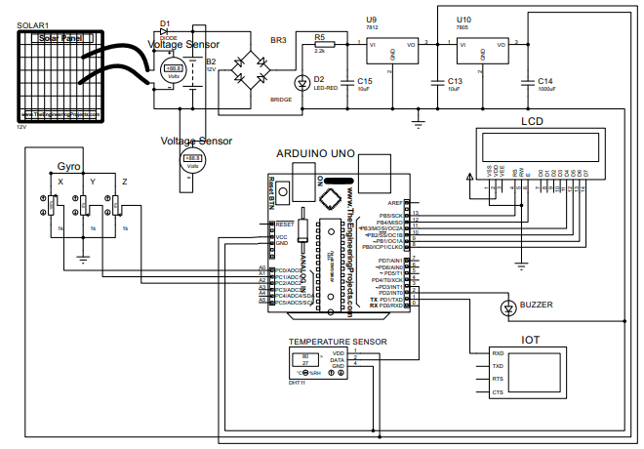

The circuit diagram of the health monitoring system includes several components that work together to provide real-time health monitoring and alerting. The Arduino microcontroller is the central unit, powered either via USB or an external battery. It processes data received from various sensors such as the gyroscope, temperature sensor, and voltage sensor. The gyroscope detects movement and orientation, continuously monitoring for falls, and connects to the Arduino through the I2C communication pins (SDA and SCL). The temperature sensor is powered by the Arduino’s 5V pin, with its data pin connected to an analog or digital input of the Arduino. It tracks the body temperature and triggers alerts if the temperature exceeds a predefined threshold. Similarly, the voltage sensor monitors the battery’s voltage level and sends data to an analog pin on the Arduino. If the battery level drops too low, the system generates an alert. The LCD display is powered by the Arduino’s 5V pin and communicates with the microcontroller via data and control pins. It shows real-time health data, including the user’s body temperature and fall status. A buzzer is connected to a digital pin on the Arduino, which is triggered when a critical event, such as a high temperature or fall detection, occurs. For IoT functionality, an external Wi-Fi module (like the ESP8266 or ESP32) connects to the Arduino via serial communication (TX/RX pins) and sends the sensor data to a cloud platform or mobile device for remote monitoring.

**CHAPTER-4**

**SOFTWARE REQUIREMENTS**

**4.1 ARDUINO IDE**

The Arduino integrated development environment (IDE) is a cross-platform application (for Windows, macOS, Linux) that is written in the programming language Java. It is used to write and upload programs to Arduino board. The source code for the IDE is released under the GNU General Public License, version 2. The Arduino IDE supports the languages C and C++ using special rules of code structuring.The Arduino IDE supplies a software library from the Wiring project, which provides many common input and output procedures. User-written code only requires two basic functions, for starting the sketch and the main program loop, that are compiled and linked with a program stub main() into an executable cyclic executive program with the GNU tool chain, also included with the IDE distribution. The Arduino IDE employs the program argued to convert the executable code into a text file in hexadecimal encoding that is loaded into the Arduino board by a loader program in the board's firmware. Arduino is an open-source electronics platform based on easy-to-use hardware and software. Arduino boards are able to read inputs - light on a sensor, a finger on a button, or a Twitter message - and turn it into an output - activating a motor, turning on an LED, publishing something online. You can tell your board what to do by sending a set of instructions to the microcontroller on the board

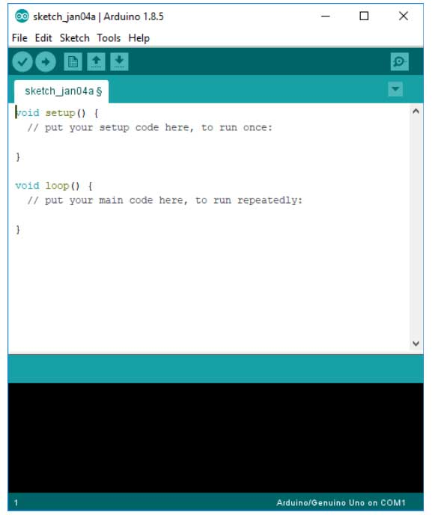

The Arduino IDE

The Arduino IDE is incredibly minimalistic, yet it provides a near-complete environment for most Arduino-based projects. The top menu bar has the standard options, including “File” (new, load save, etc.), “Edit” (font, copy, paste, etc.), “Sketch” (for compiling and programming), “Tools” (useful options for testing projects), and “Help”. The middle section of the IDE is a simple text editor that where you can enter the program code. The bottom section of the IDE is dedicated to an output window that is used to see the status of the compilation, how much memory has been used, any errors that were found in the program, and various other useful messages. Projects made using the Arduino are called sketches, and such sketches are usually written in a cut-down version of C++ (a number of C++ features are not included). Because programming a microcontroller is somewhat different from programming a computer, there are a number of device-specific libraries (e.g., changing pin modes, output data on pins, reading analog values, and timers). This sometimes confuses users who think Arduino is programmed in an “Arduino language.” However, the Arduino is, in fact, programmed in C++. It just uses unique libraries for the device. The Arduino Integrated Development Environment - or Arduino Software (IDE) - contains a text editor for writing code, a message area, a text console, a toolbar with buttons for common functions and a series of menus. It connects to the Arduino and Genuine hardware to upload programs and communicate with them. Programs written using Arduino Software (IDE) are called **sketches**. These sketches are written in the text editor and are saved with the file extension .ino. The editor has features for cutting/pasting and for searching/replacing text. The message area gives feedback while saving and exporting and also displays errors. The console displays text output by the Arduino Software (IDE), including complete error messages and other information. The bottom right hand corner of the window displays the configured board and serial port. The toolbar buttons allow you to verify and upload programs, create, open, and save sketches, and open the serial monitor.

**LIBRARIES**

Libraries provide extra functionality for use in sketches, e.g. working with hardware or manipulating data. To use a library in a sketch, select it from the **Sketch > Import Library** menu. This will insert one or more **#include** statements at the top of the sketch and compile the library with your sketch. Because libraries are uploaded to the board with your sketch, they increase the amount of space it takes up. If a sketch no longer needs a library, simply delete its **#include** statements from the top of your code. There is a list of libraries in the reference. Some libraries are included with the Arduino software. Others can be downloaded from a variety of sources or through the Library Manager. Starting with version 1.0.5 of the IDE, you do can import a library from a zip file and use it in an open sketch. **CONNECTING THE ARDUINO**

Connecting an Arduino board to your PC is quite simple. On Windows:

1. Plug in the USB cable - one end to the PC, and one end to the Arduino board.

2. When prompted, select "Browse my computer for driver" and then select the folder to which you extracted your original Arduino IDE download.

3. You may receive an error that the board is not a Microsoft certified device - select “Install anyway.”

4. Your bord should now be ready for programming.

When programming your Arduino board it is important to know what COM port the Arduino is using on your PC. On Windows, navigate to Start->Devices and Printers, and look for the Arduino. The COM port will be displayed underneath. Alternatively, the message telling you that the Arduino has been connected successfully in the lower-left hand corner of your screen usually specifies the COM port is it using.

**PREPARING THE BOARD**

Before loading any code to your Arduino board, you must first open the IDE. Double click the Arduino .exe file that you downloaded earlier. A blank program, or "sketch," should open. The Blink example is the easiest way to test any Arduino board. Within the Arduino window, it can be found under File->Examples->Basics->Blink.

Before the code can be uploaded to your board, two important steps are required.

1. Select your Arduino from the list under Tools->Board. The standard board used in RBE 1001, 2001, and 2002 is the Arduino Mega 2560, so select the "Arduino Mega 2560 or Mega ADK" option in the dropdown.

2. Select the communication port, or COM port, by going to Tools->Serial Port.

If you noted the COM port your Arduino board is using, it should be listed in the dropdown menu. If not, your board has not finished installing or needs to be reconnected.

**LOADING CODE**

The upper left of the Arduino window has two buttons: A checkmark to Verify your code, and a right-facing arrow to upload it. Press the right arrow button to compile and upload the Blink example to your Arduino board. The black bar at the bottom of the Arduino window is reserved for messages indicating the success or failure of code uploading. A "Completed Successfully" message should appear once the code is done uploading to your board. If an error message appears instead, check that you selected the correct board and COM port in the Tools menu, and check your physical connections. If uploaded successfully, the LED on your board should blink on/off once every second. Most Arduino boards have an LED prewired to pin 13.

It is very important that you do not use pins 0 or 1 while loading code. It is recommended that you do not use those pins ever. Arduino code is loaded over a serial port to the controller. Older models use an FTDI chip which deals with all the USB specifics. Newer models have either a small AVR that mimics the FTDI chip or a built-in USB-to-serial port on the AVR micro-controller itself.

**4.2 Proteus**

The Proteus Design Suite is a proprietary software tool suite used primarily for electronic design automation. The software is used mainly by electronic design engineers and technicians to create schematics and electronic prints for manufacturing printed circuit boards. Proteus is design software developed by Lab center Electronics for electronic circuit simulation, schematic capture and PCB design. Its simplicity and user friendly design made it popular among electronics hobbyists. Proteus is commonly used for digital simulations such as microcontrollers and microprocessors. It can simulate LED, LDR, USB Communication. [Proteus](http://www.labcenter.com/download/prodemo_download.cfm#professional) is a simulation and design software tool developed by [Lab center Electronics](http://www.labcenter.com/index.cfm)for [Electrical](http://www.circuitstoday.com/circuit-design-and-simulation-softwares) [and Electronic circuit design](http://www.circuitstoday.com/circuit-design-and-simulation-softwares). It also possess [2D CAD drawing feature](http://www.circuitstoday.com/electronics-circuit-drawing-softwares). It deserves to bear the tagline “From concept to completion”.

**About Proteus**

* It is a software suite containing [schematic](http://www.circuitstoday.com/pcb-design-and-layout-software), [simulation](http://www.circuitstoday.com/circuit-design-and-simulation-softwares) as well as [PCB designing](http://www.circuitstoday.com/how-to-build-pcb-online-using-web-based-eda-tools).
* [ISIS](http://www.labcenter.com/products/pcb/schematic_intro.cfm) is the software used to draw schematics and simulate the circuits in real time. The simulation allows human access during run time, thus providing real time simulation.
* [ARES](http://www.labcenter.com/products/pcb/pcb_intro.cfm)  is used for PCB designing. It has the feature of viewing output in 3D view of the designed PCB along with components.
* The designer can also develop 2D drawings for the product.

**Features**

ISIS has wide range of components in its library. It has sources, signal generators, measurement  and analysis tools like [oscilloscope](http://www.circuitstoday.com/best-analog-oscilloscope-guide), voltmeter, ammeter etc., probes for real time monitoring of the parameters of the circuit, [switches](http://www.circuitstoday.com/proteus-tutorial-switches-and-relays), [displays](http://www.circuitstoday.com/proteus-tutorial-led-and-bar-graph), loads like motors and lamps, discrete components like resistors, capacitors, inductors, transformers, digital and analog Integrated circuits, semi-conductor switches, relays, microcontrollers, processors, sensors etc.

**HISTORY**

The first version of what is now the Proteus Design Suite was called PC-B and was written by the company chairman, John Jameson, for DOS in 1988. Schematic Capture support followed in 1990, with a port to the Windows environment shortly thereafter. Mixed mode SPICE Simulation was first integrated into Proteus in 1996 and microcontroller simulation then arrived in Proteus in 1998. Shape based auto routing was added in 2002 and 2006 saw another major product update with 3D Board Visualization. More recently, a dedicated IDE for simulation was added in 2011 and MCAD import/export was included in 2015. Support for high speed design was added in 2017.  Feature led product releases are typically biannual, while maintenance based service packs are released as required.

**PRODUCT MODULES**

The Proteus Design Suite is a Windows application for [schematic capture](https://en.wikipedia.org/wiki/Schematic_capture), [simulation](https://en.wikipedia.org/wiki/Computer_simulation), and PCB ([Printed Circuit Board](https://en.wikipedia.org/wiki/Printed_Circuit_Board)) layout design. It can be purchased in many configurations, depending on the size of designs being produced and the requirements for microcontroller simulation. All PCB Design products include an auto-router and basic mixed mode SPICE simulation capabilities.

**Schematic Capture**

Schematic capture in the Proteus Design Suite is used for both the simulation of designs and as the design phase of a PCB layout project. It is therefore a core component and is included with all product configurations.

**Microcontroller Simulation**

The micro-controller simulation in Proteus works by applying either a hex file or a debug file to the microcontroller part on the schematic. It is then co-simulated along with any analog and digital electronics connected to it. This enables its use in a broad spectrum of project prototyping in areas such as motor control, temperature control and user interface design. It also finds use in the general hobbyist community and, since no hardware is required, is convenient to use as a training or teaching tool. Support is available for co-simulation of:

* [Microchip Technologies](https://en.wikipedia.org/wiki/Microchip_Technology) PIC10, PIC12, PIC16, PIC18, PIC24, dsPIC33 Microcontrollers.
* [Atmel](https://en.wikipedia.org/wiki/Atmel) AVR (and [Arduino](https://en.wikipedia.org/wiki/Arduino)), 8051 and [ARM Cortex-M3](https://en.wikipedia.org/wiki/ARM_Cortex-M#Cortex-M3) Microcontrollers
* [NXP](https://en.wikipedia.org/wiki/NXP_Semiconductors) 8051, ARM7, [ARM Cortex-M0](https://en.wikipedia.org/wiki/ARM_Cortex-M#Cortex-M0) and ARM Cortex-M3 Microcontrollers.
* [Texas Instruments](https://en.wikipedia.org/wiki/Texas_Instruments) MSP430, PICCOLO DSP and ARM Cortex-M3 Microcontrollers.
* Parallax Basic Stamp, Free scale HC11, 8086 Microcontrollers.

**PCB Design**

The PCB Layout module is automatically given connectivity information in the form of a [net list](https://en.wikipedia.org/wiki/Netlist) from the schematic capture module. It applies this information, together with the user specified [design rules](https://en.wikipedia.org/wiki/Design_rule_checking) and various design automation tools, to assist with error free board design. PCB's of up to 16 copper layers can be produced with design size limited by product configuration.

**3D Verification**

The 3D Viewer module allows the board under development to be viewed in 3D together with a semi-transparent height plane that represents the boards enclosure. [STEP](https://en.wikipedia.org/wiki/ISO_10303-21) output can then be used to transfer to mechanical CAD software such as [Solid works](https://en.wikipedia.org/wiki/Solidworks) or [Autodesk](https://en.wikipedia.org/wiki/Autodesk) for accurate mounting and positioning of the board.

**PROTEUS SIMULATIONS**

Proteus's simulation feature. Many of the components in Proteus can be simulated. There are two options for simulating: Run simulator and advance frame by frame. The "Run simulator" option simulates the circuit in a normal speed (If the circuit is not heavy). "Advance frame by frame" option advances to next frame and waits till you click this button for the next time. This can be useful for debugging digital circuits.  
You can also simulate microcontrollers. The microcontrollers which can be simulated include PIC24, dsPIC33, 8051, Arduino, ARM7 based microcontrollers. You can download the compilers for Proteus or use different compiler and dump the hex files in the microcontroller in Proteus. You can even interact in real-time with the simulation using switches, resistors, LDRs, etc. There are even virtual voltmeter, ammeter, oscilloscope, logic analyser, etc.

##### **Advantages of Proteus ISIS Professional:-**

1. It gives the proper idea and implementation of your code and circuit before implementing on hardware.  
2. It reduces the time on creating hardware and testing your errors directly on hardware. You can analyses your circuit and code both on Proteus and find the errors encountering before implementing on hardware.  
3. Reduces project cost and software dependency.

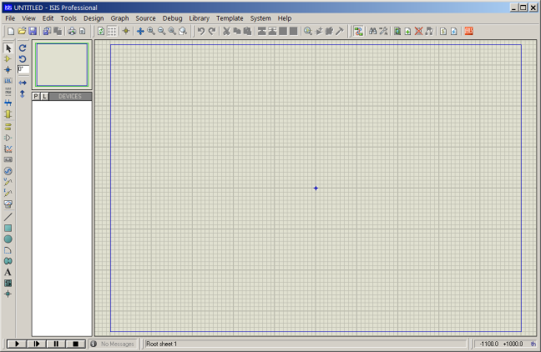

**CHAPTER-5**

**HARDWARE REQUIREMENTS**

**5.1 POWER SUPPLY CIRCUIT:**

Power supply is a reference to a source of electrical power. A device or system that supplies electrical or other types of energy to an output load or group of loads is called a power supply unit or PSU. The term is most commonly applied to electrical energy supplies, less often to mechanical ones, and rarely to others. Power supplies for electronic devices can be broadly divided into linear and switching power supplies. The linear supply is a relatively simple design that becomes increasingly bulky and heavy for high current devices; voltage regulation in a linear supply can result in low efficiency. A switched-mode supply of the same rating as a linear supply will be smaller, is usually more efficient, but will be more complex.

**Linear Power supply:**

An AC powered linear power supply usually uses a transformer to convert the voltage from the wall outlet (mains) to a different, usually a lower voltage. If it is used to produce DC, a rectifier is used. A capacitor is used to smooth the pulsating current from the rectifier. Some small periodic deviations from smooth direct current will remain, which is known as ripple. These pulsations occur at a frequency related to the AC power frequency (for example, a multiple of 50 or 60 Hz).

### Transformer:

### transformer symbol

**Transformer**

### Transformers convert AC electricity from one voltage to another with little loss of power. Transformers work only with AC and this is one of the reasons why mains electricity is AC.

### Step-up transformers increase voltage, step-down transformers reduce voltage. Most power supplies use a step-down transformer to reduce the dangerously high mains voltage (230V in UK) to a safer low voltage. The input coil is called the primary and the output coil is called the secondary. There is no electrical connection between the two coils; instead they are linked by an alternating magnetic field created in the soft-iron core of the transformer. The two lines in the middle of the circuit symbol represent the core. Transformers waste very little power so the power out is (almost) equal to the power in. Note that as voltage is stepped down current is stepped up. The ratio of the number of turns on each coil, called the turn’s ratio, determines the ratio of the voltages. A step-down transformer has a large number of turns on its primary (input) coil which is connected to the high voltage mains supply, and a small number of turns on its secondary (output) coil to give a low output voltage.

**Bridge rectifier:**

A bridge rectifier can be made using four individual diodes, but it is also available in special packages containing the four diodes required. It is called a full-wave rectifier because it uses the entire AC wave (both positive and negative sections). 1.4V is used up in the bridge rectifier because each diode uses 0.7V when conducting and there are always two diodes conducting, as shown in the diagram below. Bridge rectifiers are rated by the maximum current they can pass and the maximum reverse voltage they can withstand (this must be at least three times the supply RMS voltage so the rectifier can withstand the peak voltages). Please see the DIODES page for more details, including pictures of bridge rectifiers.

### Full-wave Varying DC

### Bridge rectifier

### Alternate pairs of diodes conduct, changing over the connections so the alternating directions of AC are converted to the one direction of DC.

### Output: full-wave varying DC: (using the entire AC wave):

### Smoothing:

### Smoothing is performed by a large value electrolytic capacitor connected across the DC supply to act as a reservoir, supplying current to the output when the varying DC voltage from the rectifier is falling. The diagram shows the unsmoothed varying DC (dotted line) and the smoothed DC (solid line). The capacitor charges quickly near the peak of the varying DC, and then discharges as it supplies current to the output.

### Smoothing

### Fig. Smoothing

### Note that smoothing significantly increases the average DC voltage to almost the peak value (1.4 × RMS value). For example 6V RMS AC is rectified to full wave DC of about 4.6V RMS (1.4V is lost in the bridge rectifier), with smoothing this increases to almost the peak value giving 1.4 × 4.6 = 6.4V smooth DC.

### Smoothing is not perfect due to the capacitor voltage falling a little as it discharges, giving a small ripple voltage. For many circuits a ripple which is 10% of the supply voltage is satisfactory and the equation below gives the required value for the smoothing capacitor. A larger capacitor will give fewer ripples. The capacitor value must be doubled when smoothing half-wave DC.

### Smoothing Capacitor for 10% ripple, C=5*10/vs.*f

### C = smoothing capacitance in farads (F)

### Io = output current from the supply in amps (A)

### Vs = supply voltage in volts (V), this is the peak value of the unsmoothed DC

### f    = frequency of the AC supply in hertz (Hz), 50Hz in the UK.

### Smooth DC power supply, transformer + rectifier + smoothing

### Fig. power supply circuit

The smooth DC output has a small ripple. It is suitable for most electronic circuits.

### Regulator:

### Voltage regulator ICs are available with fixed (typically 5, 12 and 15V) or variable output voltages. They are also rated by the maximum current they can pass. Negative voltage regulators are available, mainly for use in dual supplies. Most regulators include some automatic protection from excessive current ('overload protection') and overheating ('thermal protection'). The LM78XX series of three terminal regulators is available with several fixed output voltages making them useful in a wide range of applications. One of these is local on card regulation, eliminating the distribution problems associated with single point regulation. The voltages available allow these regulators to be used in logic systems, instrumentation, Hi-Fi, and other solid state electronic equipment. Although designed primarily as fixed voltage regulators these devices can be used with external components to obtain adjustable voltages and current. Many of the fixed voltage regulator ICs has 3 leads and look like power transistors, such as the 7805 +5V 1A regulator shown on the right. They include a hole for attaching a heat sink if necessary.

1. Positive regulator
   1. input pin
   2. ground pin
   3. output pin

It regulates the positive voltage

1. Negative regulator
   1. ground pin
   2. input pin
   3. output pin

It regulate the negative voltage

### Voltage regulator

### Regulated DC power supply, transformer + rectifier + smoothing + regulator

The regulated DC output is very smooth with no ripple. It is suitable for all electronic circuits.

**4.7ARDUINO UNO**

ARDUINO is an open-source computer hardware and software company, project and user community that designs and manufactures microcontroller-based kits for building digital devices and interactive objects that can sense and control objects in the physical world. The project is based on microcontroller board designs, manufactured by several vendors, using various microcontrollers. These systems provide sets of digital and analog I/O pins that can be interfaced to various expansion boards ("shields") and other circuits. The boards feature serial communications interfaces, including USB on some models, for loading programs from personal computers. For programming the microcontrollers, the Arduino project provides an integrated development environment (IDE) based on the Processing project, which includes support for the C and C++ programming languages. The first Arduino was introduced in 2005, aiming to provide an inexpensive and easy way for novices and professionals to create devices that interact with their environment using sensors and actuators. Common examples of such devices intended for beginner hobbyists include simple robots, thermostats, and motion detectors.

**ADVANTAGES:**

* Using an Arduino simplifies the amount of hardware and software development you need to do in order to get a system running.
* The Arduino hardware platform already has the power and reset circuitry setup as well as circuitry to program and communicate with the microcontroller over USB.
* The I/O pins of the microcontroller are typically already fed out to sockets/headers for easy access (This may vary a bit with the specific model).
* On the software side, Arduino provides a number of libraries to make programming the microcontroller easier.
* The simplest of these are functions to control and read the I/O pins rather than having to fiddle with the bus/bit masks normally used to interface with the Atmega I/O (This is a fairly minor inconvenience).
* More useful are things such as being able to set I/O pins to PWM at a certain duty cycle using a single command or doing Serial communication.

The advantages of using an Arduino over just using the underlying microcontroller:

* The whole point of the "Arduino Platform" is to allow for easy and fast prototyping.
* Being able to just hook up an LCD and be able to display messages on it in a matter of minutes, instead of hours, is just amazingly powerful and convenient when you have an idea in your head and just want to see if it works.
* When you need more control and are actually thinking on converting your prototype into a real product, then yes, you need to get deep down into the microcontroller and get rid of all the excess fat, trim the circuit to just the bare bones, optimize the code, etc.
* For prototyping, the Arduino platform gives you a lot of pre-wiring and free code libraries that will let you concentrate on testing your idea instead of spending your time building supporting circuitry or writing tons of low level code.

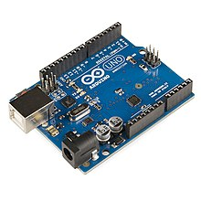

**FEATURES:**

• High Performance, Low Power AVR® 8-Bit Microcontroller

• Advanced RISC Architecture – 131 Powerful Instructions – Most Single Clock Cycle Execution – 32 x 8 General Purpose Working Registers – Fully Static Operation – Up to 20 MIPS Throughput at 20 MHz – On-chip 2-cycle Multiplier

• High Endurance Non-volatile Memory Segments – 4/8/16/32K Bytes of In-System Self-Programmable Flash progam memory (ATmega48PA/88PA/168PA/328P) – 256/512/512/1K Bytes

EEPROM:

(ATmega48PA/88PA/168PA/328P) – 512/1K/1K/2K Bytes Internal SRAM (ATmega48PA/88PA/168PA/328P) – Write/Erase Cycles: 10,000 Flash/100,000

EEPROM – Data retention:

20 years at 85°C/100 years at 25°C (1) – Optional Boot Code Section with Independent Lock Bits In-System Programming by On-chip Boot Program True Read-While-Write Operation – Programming Lock for Software Security

• Peripheral Features – Two 8-bit Timer/Counters with Separate Prescaler and Compare Mode – One 16-bit Timer/Counter with Separate Prescaler, Compare Mode, and Capture Mode – Real Time Counter with Separate Oscillator – Six PWM Channels – 8-channel 10-bit ADC in TQFP and QFN/MLF package

Temperature Measurement – 6-channel 10-bit ADC in PDIP Package Temperature Measurement – Programmable Serial USART – Master/Slave SPI Serial Interface – Byte-oriented 2-wire Serial Interface (Philips I2 C compatible) – Programmable Watchdog Timer with Separate On-chip Oscillator – On-chip Analog Comparator – Interrupt and Wake-up on Pin Change

• Special Microcontroller Features – Power-on Reset and Programmable Brown-out Detection – Internal Calibrated Oscillator – External and Internal Interrupt Sources – Six Sleep Modes: Idle, ADC Noise Reduction, Power-save, Power-down, Standby, and Extended Standby

• I/O and Packages – 23 Programmable I/O Lines – 28-pin PDIP, 32-lead TQFP, 28-pad QFN/MLF and 32-pad QFN/MLF • Operating Voltage: – 1.8 - 5.5V for ATmega48PA/88PA/168PA/328P • Temperature Range: – -40°C to 85°C • Speed Grade: – 0 - 20 MHz @ 1.8 - 5.5V

• Low Power Consumption at 1 MHz, 1.8V, 25°C for ATmega48PA/88PA/168PA/328P: – Active Mode: 0.2 mA – Power-down Mode: 0.1 µA – Power-save Mode: 0.75 µA (Including 32 kHz RTC)

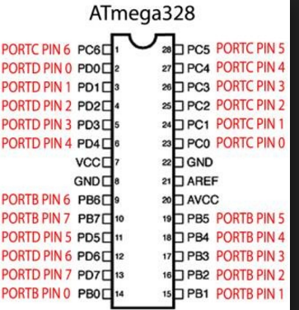

**4.8 LIQUID CRYSTAL DISPLAY**

A liquid crystal display (LCD) is a flat panel display, electronic visual display, or video display that uses the light modulating properties of liquid crystals. Liquid crystals do not emit light directly. LCDs are available to display arbitrary images (as in a general-purpose computer display) or fixed images which can be displayed or hidden, such as preset words, digits, and 7-segment displays as in a digital clock. They use the same basic technology, except that arbitrary images are made up of a large number of small pixels, while other displays have larger elements. An LCD is a small low cost display. It is easy to interface with a micro-controller because of an embedded controller (the black blob on the back of the board). This controller is standard across many displays (HD 44780) which means many micro-controllers (including the Arduino) have libraries that make displaying messages as easy as a single line of code.

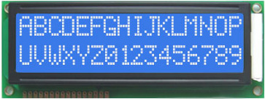

LCDs are used in a wide range of applications including computer monitors, televisions, instrument panels, aircraft cockpit displays, and signage. They are common in consumer devices such as video players, gaming devices, clocks, watches, calculators, and telephones, and have replaced cathode ray tube (CRT) displays in most applications. They are available in a wider range of screen sizes than CRT and plasma displays, and since they do not use phosphors, they do not suffer image burn-in. LCDs are, however, susceptible to image persistence.

|  |  |  |
| --- | --- | --- |
| **Pin No** | **Function** | **Name** |
| 1 | Ground (0V) | Ground |
| 2 | Supply voltage; 5V (4.7V – 5.3V) | Vcc |
| 3 | Contrast adjustment; through a variable resistor | VEE |
| 4 | Selects command register when low; and data register when high | Register Select |
| 5 | Low to write to the register; High to read from the register | Read/write |
| 6 | Sends data to data pins when a high to low pulse is given | Enable |
| 7 | 8-bit data pins | DB0 |
| 8 | DB1 |
| 9 | DB2 |
| 10 | DB3 |
| 11 | DB4 |
| 12 | DB5 |
| 13 | DB6 |
| 14 | DB7 |
| 15 | Backlight VCC (5V) | Led+ |
| 16 | Backlight Ground (0V) | Led- |

**6.2 CONCLUSION**

In conclusion, the health monitoring system developed in this project offers an innovative and comprehensive solution to address key challenges in ensuring the safety and well-being of individuals, particularly those at risk of falls, temperature fluctuations, and battery failure. By integrating fall detection, temperature monitoring, and battery voltage tracking with a user-friendly interface and IoT functionality, the system provides a proactive approach to health management. Use of a gyroscope for fall detection ensures that caregivers are immediately alerted in case of a fall, allowing for timely intervention and reducing the risk of serious injury. Temperature monitoring further enhances the system’s capability by providing early warnings for abnormal temperature changes, such as fever or hypothermia, which can indicate underlying health issues requiring immediate medical attention. Additionally, the inclusion of a battery monitoring system ensures that the health monitoring system operates without interruptions, preventing system failures and ensuring consistent functionality. Real-time data displayed on the LCD screen, coupled with the IoT integration for remote monitoring, makes this system highly effective for caregivers. It enables them to monitor health parameters from a distance, receive alerts for critical events, and intervene promptly when necessary. This capability not only improves the efficiency of caregiving but also provides peace of mind to families and healthcare professionals who may not always be present. System serves as a practical tool for improving the quality of care and safeguarding individuals, especially the elderly and those with health conditions that put them at risk of falls or other emergencies. Its integration of sensors, real-time data processing, and remote access capabilities represents a significant advancement in healthcare technology. With further refinement and expansion, this system can serve as a foundational platform for more sophisticated health monitoring solutions, helping to reduce the burden on caregivers, prevent emergencies, and enhance the overall quality of life for individuals in need of constant health surveillance.

**6.3 FUTURE ENHANCEMENT**

The health monitoring system developed in this project provides a strong foundation for improving the safety and well-being of individuals who are at risk of falls, temperature fluctuations, and battery failure. However, there are several areas where future enhancements can make the system even more effective and versatile. One potential improvement would be the integration of additional sensors to monitor a broader range of health parameters, such as heart rate, oxygen saturation, and blood pressure. These sensors would allow for a more comprehensive health profile and provide caregivers with real-time data on multiple critical health indicators. Adding more sensors would not only improve the system’s functionality but also make it more applicable to users with different health needs. Another significant enhancement would be the inclusion of machine learning algorithms for predictive analytics. By analyzing historical data and recognizing patterns, the system could anticipate potential health issues before they occur. For example, it could detect a higher risk of falls based on movement patterns or predict temperature-related health conditions. Machine learning could also help improve the system’s ability to detect anomalies, refine alert thresholds, and reduce false positives, providing caregivers with more reliable notifications. Improving the system’s IoT connectivity is another area of potential enhancement. Expanding the system’s compatibility with a wider variety of platforms would allow for seamless integration into existing healthcare ecosystems. Connecting the system to more devices, such as health-specific mobile apps or wearable health technology, would enable caregivers and medical professionals to monitor the user’s health data more effectively. Additionally, the use of more robust and reliable IoT communication protocols could increase the system’s stability and performance. Adding voice activation and communication features could further enhance the system’s user experience, particularly for individuals with mobility impairments or limited dexterity. With voice recognition or voice command capabilities, users could interact with the system to check their health status or trigger specific actions, such as sending an alert or checking battery levels. Furthermore, integrating a two-way communication system would allow caregivers to provide instructions or reassurance in case of an emergency, improving the response time and support offered to the user.

**REFERENCE:**

1. A. A. Mohamed, M. A. M. El-Sayed, and N. K. Ahmed, "Wearable Health Monitoring Systems: A Comprehensive Review," IEEE Access, vol. 8, pp. 102112–102136, 2020. doi:10.1109/ACCESS.2020.2999012.
2. M. S. Islam, M. S. Kaiser, and R. R. Amin, "IoT-Based Smart Health Monitoring System: Architecture, Applications, and Challenges," IEEE Access, vol. 9, pp. 110043–110061, 2021. doi:10.1109/ACCESS.2021.3052994.
3. H. S. Kang, S. H. Kim, and J. K. Lee, "Smart Health Monitoring Systems and their Applications: A Review," IEEE Sensors Journal, vol. 21, no. 14, pp. 1523–1535, 2021. doi:10.1109/JSEN.2021.3068295.
4. R. S. M. G. G. Karuppiah, V. S. M. R. Sivathanu, and A. Kumar, "Survey on Smart Healthcare Systems: Recent Advances and Future Directions," IEEE Internet of Things Journal, vol. 8, no. 7, pp. 5725–5736, 2021. doi:10.1109/JIOT.2021.3051816.
5. J. K. Patel, A. Y. R. Khan, and T. S. B. Lee, "Advancements in Wearable Health Monitoring Systems: A Review and Future Trends," IEEE Access, vol. 9, pp. 162423–162441, 2021. doi:10.1109/ACCESS.2021.3124651.
6. L. J. Yan, Y. H. Chen, and C. Y. Yu, "Smart Healthcare Systems: An Overview of Recent Developments and Future Research," IEEE Transactions on Industrial Informatics, vol. 17, no. 4, pp. 2472–2484, 2021. doi:10.1109/TII.2021.3061429.
7. T. C. P. S. R. D. Kumar, S. A. M. S. Amoud, and B. K. M. Kar, "Wireless Health Monitoring System: Emerging Trends and Challenges," IEEE Transactions on Biomedical Engineering, vol. 68, no. 7, pp. 2492–2505, 2021. doi:10.1109/TBME.2021.3064682.
8. P. T. R. S. R. P. Srinivas, S. J. Krishnan, and M. R. M. Rai, "IoT and Machine Learning for Healthcare Monitoring Systems: A Survey of Recent Developments," IEEE Transactions on Emerging Topics in Computing, vol. 9, no. 1, pp. 55–68, 2021. doi:10.1109/TETC.2020.3027031.
9. M. R. P. A. P. D. S. P. Ghosh, "Health Monitoring Systems for Smart Homes: Design, Applications, and Challenges," IEEE Access, vol. 10, pp. 67244–67258, 2022. doi:10.1109/ACCESS.2022.3173842.
10. A. T. S. N. Y. Tan, R. N. M. G. V. Raman, and S. K. G. Jain, "A Review of Smart Health Monitoring Devices and Their Applications," IEEE Access, vol. 8, pp. 132685–132702, 2020. doi:10.1109/ACCESS.2020.3009826.